Building Java Programs
Chapter 8 Lab Handout

Classes
1. Define a class named RandomWalker. A RandomWalker object should keep track of its (x, y) location. All walkers start at the coordinates (0, 0). When a walker is asked to move, it randomly moves either left, right, up or down. Each of these four moves should occur with equal probability. The resulting behavior is known as a "random walk." (A 2-dimensional random walk example is pictured at right.)
Each RandomWalker object should have the following public methods. You may add whatever fields or methods you feel are necessary to implement these methods:
move()
Instructs this random walker to randomly make one of the 4 possible moves (up, down, left, or right).
getX()
Returns this random walker's current x-coordinate.
getY()
Returns this random walker's current y-coordinate.
getSteps()
Returns the number of steps this random walker has taken.
Random walks have interesting mathematical properties. For example, given infinitely many steps, a random walker approaches 100% chance of reaching a particular (x, y) coordinate. To learn more about random walks, visit http://mathworld.wolfram.com/RandomWalk.html .
Test your RandomWalker by running it with the TestRandomWalker test class, found on the Labs section of the course web site. The TestRandomWalker will run your random walker in a loop and animate its position as it moves.
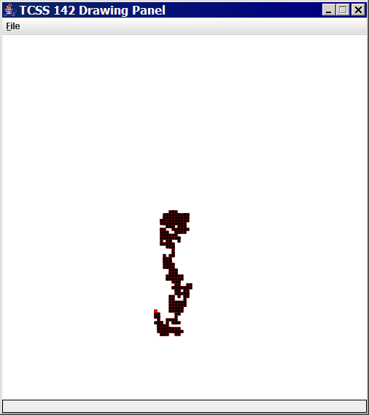
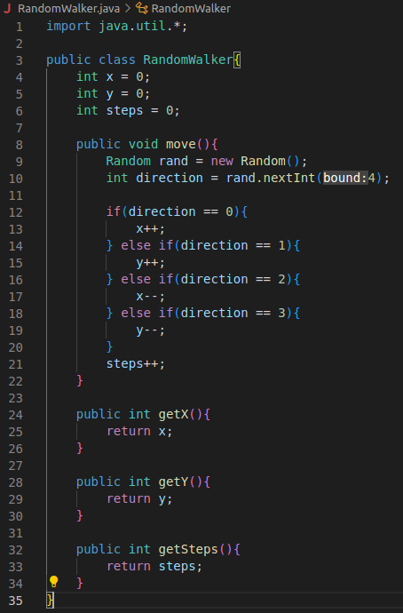
2. Define a class named Rectangle. A Rectangle object stores an (x, y) coordinate of its top/left corner, a width, and a height.
Each Rectangle object should have the following public methods:
Rectangle(x, y, width, height)
Constructs a new rectangle whose top-left corner is specified by the given coordinates and with the given width and height.
getX()
Returns this rectangle's leftmost x-coordinate.
getY()
Returns this rectangle's top y-coordinate.
getWidth()
Returns this rectangle's width.
getHeight()
Returns this rectangle's height.
toString()
Returns a String representation of this rectangle, such as "Rectangle[x=1,y=2,width=3,height=4]".
contains(x, y)
Returns whether the given Point's coordinates lie inside the bounds of this rectangle.
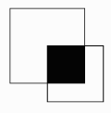
intersect(rect)
Turns this rectangle into the intersection of itself and the given other rectangle rect; that is, the largest rectangular region completely contained within both this rectangle and the given other rectangle. (In the picture at right, the intersection of the two rectagles is the shaded black region.) You may assume that the two rectangles do overlap and therefore have a nonempty intersection.
equals(o)
Returns whether the given other object o is a rectangle with the same x/y coordinates, width, and height as this rectangle. You may assume that o refers to a Rectangle object.

Test your program by running it with the TestRectangle class, which is found on the Labs section of the course web site.

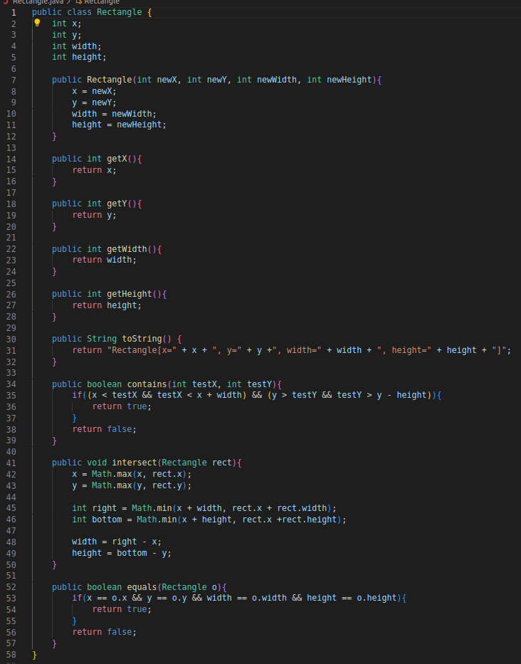
3. Define a class named CandyDistributor. A CandyDistributor object represents a hungry child who is going to divide a set of candies between herself and her hungry sibling. This will be done fairly by alternating who gets a candy. Each CandyDistributor object should have the following method:
public void nextCandy()
Each time nextCandy is called, the method prints a message about who gets a candy, and how many candies that person has. Each call to nextCandy produces a single line of output. The code below constructs a CandyDistributor object and calls its nextCandy 8 times. The output appears at right.
public class TestCandy {
public static void main(String[] args) {
CandyDistributor nice = new CandyDistributor();
nice.nextCandy(); // 1 for you.
nice.nextCandy(); // 1 for me.
nice.nextCandy(); // 2 for you.
nice.nextCandy(); // 2 for me.
nice.nextCandy(); // 3 for you.
nice.nextCandy(); // 3 for me.
nice.nextCandy(); // 4 for you.
nice.nextCandy(); // 4 for me.
}
}

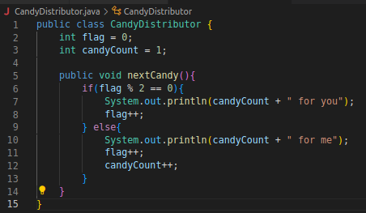

4. Define a class named UnfairCandyDistributor. An UnfairCandyDistributor object represents a mean big brother who is going to divide a set of candies between himself and his hungry little brother. This will be done unfairly: for every candy given to the sibling, the big brother takes for himself a number of additional candies equal to the younger sibling's total. Each UnfairCandyDistributor object should have the same method:
public void nextCandy()
Each time nextCandy is called, the method prints a message about who gets a candy. Each call to nextCandy produces a single line of output. This time the output is the following:
public class TestCandy2 {
public static void main(String[] args) {
UnfairCandyDistributor mean = new UnfairCandyDistributor();
mean.nextCandy(); // 1 for you.
mean.nextCandy(); // 1 for me.
mean.nextCandy(); // 2 for you.
mean.nextCandy(); // 1 for me.
mean.nextCandy(); // 2 for me.
mean.nextCandy(); // 3 for you.
mean.nextCandy(); // 1 for me.
mean.nextCandy(); // 2 for me.
mean.nextCandy(); // 3 for me.
mean.nextCandy(); // 4 for you.
mean.nextCandy(); // 1 for me.
mean.nextCandy(); // 2 for me.
mean.nextCandy(); // 3 for me.
mean.nextCandy(); // 4 for me.
}
}

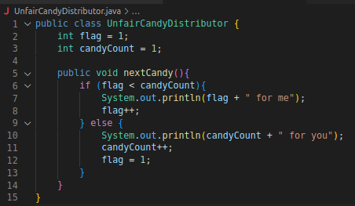
5. Define a class named TimeSpan. A TimeSpan object stores a span of time in hours and minutes (for example, the time span between Monday 8AM and Wednesday 10:30AM is 50 hours, 30 minutes). Each TimeSpan object should have the following public methods:
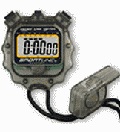
TimeSpan(hours, minutes)
Constructs a TimeSpan object storing the given time span of minutes and seconds.
add(hours, minutes)
Adds the given amount of time to the current time span (e.g. 2 hours, 15 min + 1 hour, 45 min = 4 hours). Assume that the arguments are valid: the hours are non-negative, and the minutes are between 0 and 59.
add(timespan)
Adds the given amount of time (stored as a time span) to the current time span.
getTotalHours()
Returns the total time in this time span as the real number of hours (such as 9.75 for 9 hours, 45 min).
toString()
Returns a string representation of the time span of hours and minutes, such as "28h46m".
The minutes should always be reported as being in the range of 0 to 59. That means that you may have to "carry" 60 minutes into a full hour. For example, consider the following code:
TimeSpan t1 = new TimeSpan(3, 45);
System.out.println(t1 + " is " + t1.getTotalHours() + " hours");
t1.add(2, 30);
System.out.println(t1 + " is " + t1.getTotalHours() + " hours");
TimeSpan t2 = new TimeSpan(0, 55);
t1.add(t2);
System.out.println(t1 + " is " + t1.getTotalHours() + " hours");
This code creates a TimeSpan object and adds three different times to it. The output should be:
3h45m is 3.75 hours
6h15m is 6.25 hours
7h10m is 7.166666666666667 hours
Notice that the second time is not 5 hours, 75 minutes, although that's what you'd get by just adding values.
